Module 1 – Overview of IT Industry

1. What is a Program?

ans. Program is set of instruction. it is work on particular task which i give it.

1.1. Write a simple "Hello World" program in two different programming languages of your choice. Compare the structure and syntax.

ans. #include<stdio.h>

int main(){

printf("Hello World");

return 0;

}

Structure of C: - Header File, main(), datatypes, variable, body, return type

Syntax of C: - #include<stdio.h>

int main(){

code execution

return 0;

}

1.2. Explain in your own words what a program is and how it functions.

a computer program is set of instruction. this instruction is set by computer and this instruction work on particular task.

function is main point of program when a put a function after that write a program and execute a code.

2. What is Programming?

ans. programming is process for telling computer to perform a task which i give it

programming is performing a task to a particular language.

ex. C, C++

2.1.: What are the key steps involved in the programming process?

ans. there are one of more key steps, understanding the program, planning, design a program, write code, execute a code, test that code and deploy that code.

2.2. What are the main differences between high-level and low-level programming languages?

ans. high level languages: - C, C++, Python, PHP this programming languages are high level language languages when uses functions, object etc.

low level languages: - binary language, machine language this is a low-level language in these languages use to code binary to machine code. in these languages use only 0 and 1.

3. World Wide Web & How Internet Works.

ans. www is a world wide web. this www is used to address of particular website

ex. [www.google.com](file://C:\Users\Kamlesh\OneDrive\Desktop\kamlesh\www.google.com)

internet work is different types like information, social media. any information does you need so search on google within 1 second google search this information

there are different types of internet connection: - cable, wireless, satellite, BPL etc.

3.1. Research and create a diagram of how data is transmitted from a client to a server over the internet.

ans.

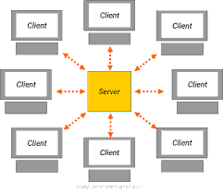

in this diagram client request to the server for particular information and server search to the information and give the client for to a secure path.

3.2. Describe the roles of the client and server in web communication.

ans. client has any device like mobile, computer, laptop in this device has a web browser, so client any information search from this device so this search goes to server.

so, this server searches an information for it and give to the client.

so, this is a web communication to client and server, client any type request to server and server give to the information.

4. Network Layers on Client and Server

ans. there are 7 layers: -

1. Physical layer

2. data link layer

3. Network layer

4. Transport layer

5. Session layer

6. Presentation layer

7. Application layer

4.1. Design a simple HTTP client-server communication in any language.

ans.

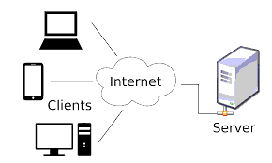

4.2. Explain the function of the TCP/IP model and its layers.

ans. TCP/IP means transmission control protocol/internet protocol. it is used to transfer the data computer to another device, this information sender sent to securely another receiver and receiver receive the data securely.

functions of TCP/Ip layers: -

application layer, transport layer, internet layer, link layer

5. Explain client server communication

ans. client a request to server for any information so server is search to this information to the best path for client when server found this information that time server response to the client and give the information for it. this process to the called client and server communication.

6.: Research different types of internet connections (e.g., broadband, fiber, satellite) and list their pros and cons.

ans. DSL(Digital Subscriber Line)

cable

Satellite

Wireless

Broadband over power lines (BPL)

Fiber

pros: -

easy and faster communication

provide information very easy

easy to connect to social network

online services

cons: -

cyber crime

spam emails and messages

internet addiction

6.1.: How does broadband differ from fiber-optic internet?

ans. broadband connection faster than fiber optics internet. fiber optic internet use to fiber optics cable to deliver a broadband connection.

7. Simulate HTTP and FTP requests using command line tools (e.g., curl).

7.1. What are the differences between HTTP and HTTPS protocols?

ans.

HTTP: -

HTTP is hypertext transfer protocol

http is providing a data but not secure

http request to the server for data and server response for the data

HTTPS: -

HTTPS is hypertext transfer protocol secure

https is providing a data securely

https same as work as http but securely.

8. Application Security.

8.1. Identify and explain three common application security vulnerabilities. Suggest possible solutions.

ans. 1) Structuree query language

2) Broken authentication

3)Cross site scripting

Use prepared statements that user input is treated as data rather than part of SQL command.

Use multiple factor authentication is password for user authentication. ex: biometrics

Input sanitization and output encoding sanitize user input to remove or escape HTML tags or scripts. use output encoding to display data safley in a web page.

8.2 What is the role of encryption in securing applications?

ans. it’s a role of data security. encrypt any data passing through an application. Data encrypted multiple layers. application layer increase security.

9.Software Applications and Its Types.

9.1 Identify and classify 5 applications you use daily as either system software or application software.

ans. application software is a program that build a specific function like business education etc...

example: - vs code, Trello, MS office, adobe photoshop, YouTube etc.

9.2. What is the difference between system software and application software?

ans. System Software: - it’s a control cup, monitor like hardware. it provides functionality to the computer this called system software. system software is developed using low level language. its operating computer hardware.

Application Software: - it’s a developed to perform a specific function is known as an application software. it’s also called end-user. Application software is using high level language for developed software. it’s used to perform specific task.

10. Software Architecture.

10.1. Design a basic three-tier software architecture diagram for a web application.

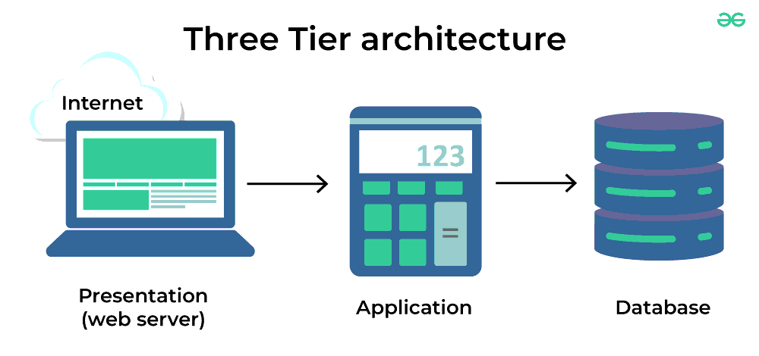

10.2. What is the significance of modularity in software architecture?

ans. its called a code breaker. larger code break in smaller section and hold specific function. this structure in which different components of a software system are divided into separate functional unit.

11. Layers in Software Architecture.

11.1: Create a case study on the functionality of the presentation, business logic, and data access layers of a given software system.

ans. Done in a lab.

11.2: Why are layers important in software architecture?

ans. there are 5 layer of software architecture 1. presentation layer, 2. application layer, 3. business layer, 4. persistence layer, 5. database layer.

this all are important for software architecture because this layer applied for any software so software work easy to develop software this process applied for develop any application more effectively.

12. Software Environments

12.1: Explore different types of software environments (development, testing, production). Set up a basic environment in a virtual machine.

ans. there are various type of environments. 1. development environment, 2. test environment, 3. staging environment, 4. production environment

12.2 Explain the importance of a development environment in software production.

Ans. A development environment is crucial because it provides a safe space to write, test, and debug code without affecting the live application. It ensures consistency, facilitates collaboration, and supports automation, leading to high-quality software production.

13. Source Code

13.1: Write and upload your first source code file to GitHub.

Ans. I create a GitHub account and in this account i create my first repository, i push my txt file.

13.2: What is the difference between source code and machine code?

Ans. Source code is human readable code. Source code is a high-level code.

Example: - python, C++ etc.

Machine code is binary code. This code understands on 0 and 1 and this code is low level code.

This code computer directly executes there are no need a compiler

14. GitHub and Introductions

14.1 Create a GitHub repository and document how to commit and push code changes.

Ans. i created GitHub account, I create my first repository and i push txt file too

14.2 Why is version control important in software development?

Ans. Because it provides a structured approach to realising, tracking, and managing software product versions. The main point is it’s a bridge between technical side and business side of product development.

15. Student Account in GitHub

15.1: Create a student account on GitHub and collaborate on a small project with a classmate.

Ans. Done in a lab.

15.2 What are the benefits of using GitHub for students?

Ans. making group projects easier to manage.

GitHub is free for learning and education.

Building online portfolio

They are show there project online and code publicly.

16. Types of Software

16.1 Create a list of software you use regularly and classify them into the following categories: system, application, and utility software.

Ans. System software: - Windows, macOS, Linux, NVIDIA/AMD

Application software: - Google Chrome, Firefox, Microsoft Edge, Visual Studio Code, Adobe Photoshop, Figma

Utility Software: - Google Drive, WinRAR

16.2 What are the differences between open-source and proprietary software?

Ans. Open-source software: - this software is free. Highly customize. this software viewed publicly.

Proprietary Software: - this software is not free there are available for purchase this software use mainly for developers there are not for free they require for licence.

17. GIT and GITHUB Training

17.1 Follow a GIT tutorial to practice cloning, branching, and merging repositories.

Ans. Done in a lab.

17.2 How does GIT improve collaboration in a software development team?

Ans. Git improves collaboration by enabling version control, allowing multiple developers to work simultaneously without conflicts.

It supports branching and merging, facilitating parallel development of features. Git platforms like GitHub enhance collaboration with tools for code reviews, issue tracking, ensuring high-quality contributions and streamlined workflows.

18. Application Software

18.1 Write a report on the various types of application software and how they improve productivity.

Ans. Application software improves productivity by streamlining tasks and automating processes. Tools like word processors, spreadsheets, and presentation software enhance document creation, data analysis, and presentation development.

these applications enable faster work, better organization, and improved decision-making, leading to enhanced productivity in personal and professional settings.

18.2 What is the role of application software in businesses?

Ans. there are a multiple role of this application software. cloud base role general business application, there in different role of this department like entertainment.

there is a various example of this CRM system, ERP system etc.

The sole purpose of application software is to assist the user in doing specified tasks.

like word, excel, chrome, edge etc.

19. Software Development Process

19.1: Create a flowchart representing the Software Development Life Cycle (SDLC).

Ans.

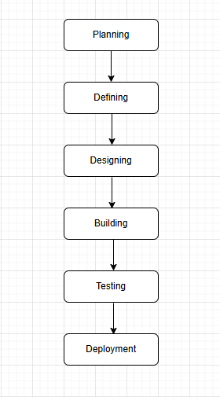

19.2 What are the main stages of the software development process?

Ans. 1. planning

2.analysis

3. design

4. implementation

5.testing

6.deployment

7.maintenance

20. Software Requirement

20.1 Write a requirement specification for a simple library management system

Ans. Functional Requirements: Book Management, User Management, Book Borrowing and Returning, Reporting and Notifications

Non-Functional Requirements: Usability, Performance, Security, Availability

External Interface Requirements: User Interfaces, Hardware Interfaces, Software Interfaces.

20.2 Why is the requirement analysis phase critical in software development?

Ans. because analysis phase is showing a whole project and clear project scope

there are many things we can’t avoid that like communication, design, cost and time, QA testing and last customer satisfaction. this phase is the requirement for the software development.

21. Software Analysis

21.1 Perform a functional analysis for an online shopping system.

Ans. User Registration, product searching, shopping cart, payment, order, review and rating, user account, dashboard.

21.2 What is the role of software analysis in the development process?

Ans. there is a main role of understanding the software system when developers a developed a software and their software analysis step by step.

what is a design which tool use for this software understanding the requirement of a software system and then designing a system that meet those requirements create a system architecture and analysis requirement create a system architecture and design.

22. System Design

22.1: Design a basic system architecture for a food delivery app.

Ans.

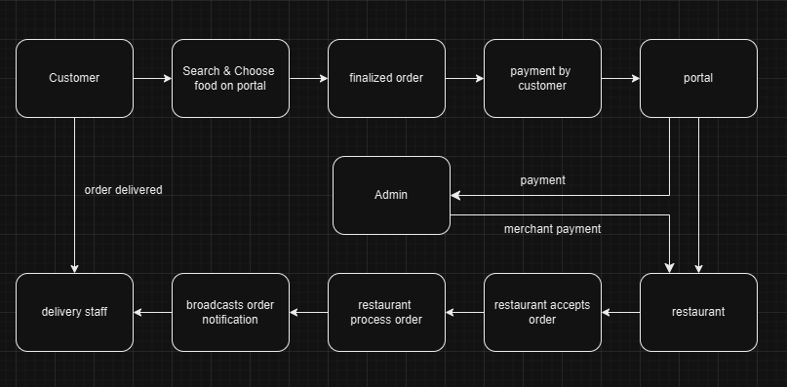

22.2 What are the key elements of system design?

Ans. The key elements of the design process include understanding the problem or need, brainstorming and generating ideas, creating prototypes or models, testing and refining the design, and finally implementing the design.

23. Software Testing

23.1 Develop test cases for a simple calculator program.

Ans. #include<stdio.h>

int main() {

int a, b, choice;

printf("Enter first number: ");

scanf("%d", &a);

printf("Enter second number: ");

scanf("%d", &b);

printf("Enter your choice\n");

printf("1. Addition\n");

printf("2. Subtraction\n");

printf("3. Multiplication\n");

printf("4. Division\n");

scanf("%d", &choice);

if (choice == 1) {

printf("%d + %d = %d\n", a, b, a + b);

} else if (choice == 2) {

printf("%d - %d = %d\n", a, b, a - b);

} else if (choice == 3) {

printf("%d \* %d = %d\n", a, b, a \* b);

} else if (choice == 4) {

if (b != 0) {

printf("%d / %d = %.2f\n", a, b, (float)a / b);

} else {

printf("Error! Division by zero is not allowed.\n");

}

} else {

printf("Invalid choice\n");

}

return 0;

}

23.2 Why is software testing important?

Ans. because they can’t test a software so how can they find software is properly work software testing is a part of learning when they check a software so they find a bug in that software and they check software work properly or not.

24. Maintenance

24.1 Document a real-world case where a software application required critical maintenance.

Ans.

24.2: What types of software maintenance are there?

Ans. Corrective Software Maintenance, Adaptive Software Maintenance, Perfective Software Maintenance, Preventive Software Maintenance.

25.Development

25.1: What are the key differences between web and desktop applications?

Ans. web application : no installation required, use different OS, require internet, internet slow so they slower, data store in cloud server, example: Gmail, Instagram

desktop application: install on the device, use windows, macOS, Linux, function offline, faster, data store in local device, example: word photoshop.

27. Web Application

27.1 What are the advantages of using web applications over desktop applications?

Ans. 1.Cross-platform compatibility

2.No installation required

3.Easier and faster updates

4.Automatic data synchronization

5.Scalable for growth

28. What role does UI/UX design play in application development?

Ans. UI means User Interface. its a create a visual interface for software application there are all designer who specialize in UI design.

UX means User Experience. its create and interactions that a user has with a product.

UI/UX design makes sure an app is easy to use, looks good, and works well. It focuses on creating a smooth and enjoyable experience for users, helping them find what they need quickly and keeping them engaged with the app.

29. Mobile Application

29.1: What are the differences between native and hybrid mobile apps?

Ans. native apps: - require installation, high maintenance, multiple codebases, best user experience, languages: - java, swift, kotlin

hybrid app: - does not require installation, low maintenance, single codebase, don’t have good user experience, languages:- html, CSS, JavaScript.

30. DFD (Data Flow Diagram)

30.1 Create a DFD for a hospital management system

Ans. 0 level DFD:

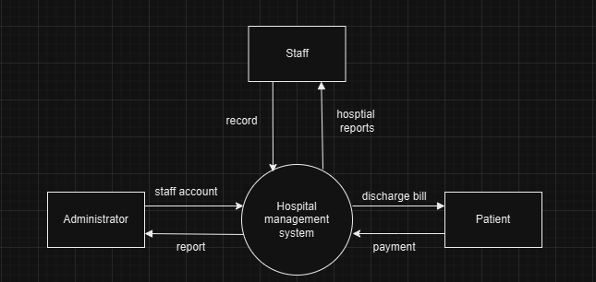

1st level DFD:

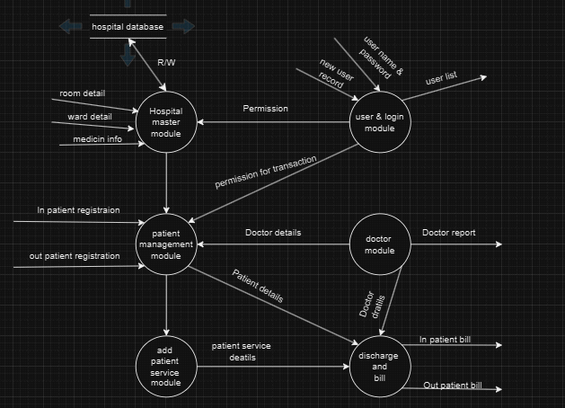

2nd level DFD:

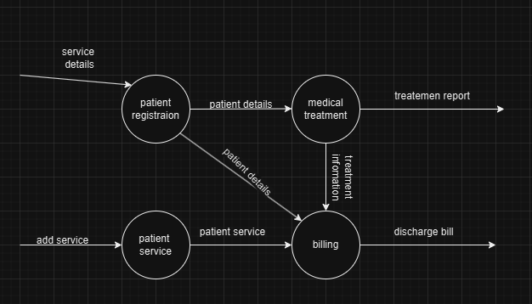

30.2: What is the significance of DFDs in system analysis?

Ans: dfd help a better understand process or system operations to discover potential problem, improve efficiency and develop better process, they are understanding a system process, they identify problem and solve it they define 3 type of level 0 level, 1st level and 2nd level, they are more flexible and scalable.

31 Desktop Application

31.1 : Build a simple desktop calculator application using a GUI library

Ans.

31.2 : : What are the pros and cons of desktop applications compared to web applications?

Ans. Desktop Applications:

Pros: Typically, faster and more responsive, unction without an internet connection, allows greater control over the system’s hardware and settings, less exposed to web-based vulnerabilities when properly installed and updated.

Cons: Requires users to download and install updates, Often requires a one-time purchase or license fee, Consumes local disk space, Tied to the device they are installed on.

Web Applications:

Pros: Available from any device with an internet connection and browser, Works across different devices and operating systems, Often free or subscription-based with no large upfront cost, Enables real-time sharing and collaboration over the web.

Cons: Requires a stable connection to function effectively, May be slower due to server-side dependencies, Functionality is usually restricted without an internet connection, Performance and compatibility can vary across browsers.

32. Flow Chart

32.1 Draw a flowchart representing the logic of a basic online registration system.

Ans.

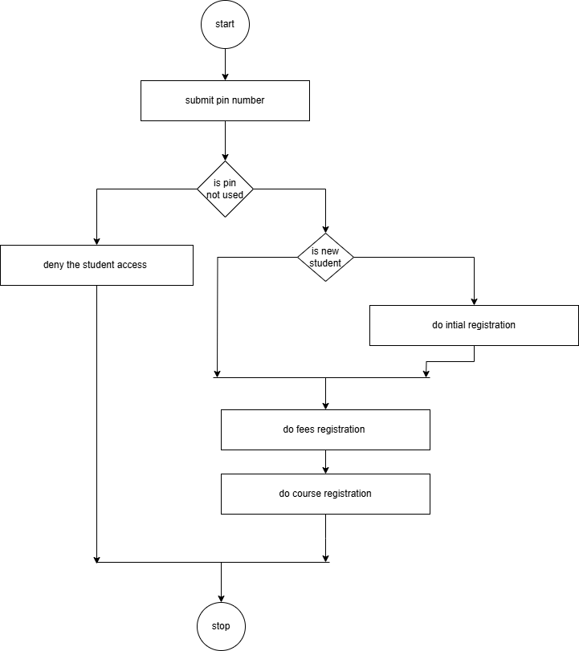

32.2: How do flowcharts help in programming and system design?

Ans. Flowcharts are essential in programming and system design as they visually represent processes, making complex logic easier to understand and analyse. They help identify errors, streamline workflows, and ensure clarity in planning and execution. By acting as a communication bridge between technical and non-technical stakeholders, flowcharts improve collaboration and decision-making. Additionally, they serve as documentation, aiding future maintenance and debugging.